# SRS VehiScan

## Introduction

Daily parking struggles are a common frustration for drivers, leading to wasted time, fuel, and energy. The **Smart Parking System** aims to transform this experience by offering a seamless and efficient solution. It provides **real-time availability of parking spots**, allowing drivers to locate and reserve parking effortlessly. By integrating features like **advance slot booking**, **predictive availability**, and **cashless payments**, our system eliminates the uncertainty and stress of finding a parking space.

Beyond improving individual convenience, the system also reduces unnecessary vehicle circulation, contributing to **fuel savings** and **lower carbon emissions**, thus promoting a more sustainable environment. This is particularly impactful in **urban areas**, where congestion is highest, and available parking is scarce.

The Smart Parking System also addresses the specific needs of **university campuses**, where parking issues are prevalent among students and staff. Our platform enables university members to pre-book spots, reducing intra-campus traffic, improving punctuality, and creating a more productive and harmonious academic environment.

With its intuitive interface, seamless navigation, and robust features, the Smart Parking System is designed to make parking simple, smart, and sustainable.

## **User Characteristics**

1. **Urban Residents**

* **Role:** Primary users relying on real-time parking updates.
* **Tech Behavior:** Regular users of mobile/web apps, often in a rush.
* **Needs:** Quick, reliable, and nearby parking solutions.

1. **Parking Authorities & Management**

* **Role:** Manage and monitor parking infrastructure and operations
* **Tech Behavior:** Use backend systems for analytics and control.

## **User Stories**

## Urban Resident Use Cases

1. Register my vehicle by entering license plate, make, model, and color.
2. Search destination by address or using an interactive map.
3. View real-time availability of parking at my destination.
4. Reserve a specific parking slot for a defined time in advance.
5. Set parking duration including start and end times.
6. View parking rates, including dynamic or time-based pricing.
7. Book available slots instantly.
8. Receive predictive availability alerts based on events and traffic patterns.
9. Choose parking floor and row when options are available.
10. Get turn-by-turn directions inside the facility.
11. Receive push notifications for newly available slots.
12. Securely add and manage payment methods (cards, wallets).
13. Pay directly through the app for a seamless cashless experience.
14. View current and past reservations.
15. Access full details of each booking (time, location, cost).
16. Quickly rebook frequent destinations via saved favorites.
17. Manage personal parking profile (vehicle, payment, preferences).
18. Access parking history records.
19. Be notified of parking violations or fines.
20. Track penalty enforcement details and resolve issues.
21. Cancel reservations easily with clear cancellation policies.
22. Report issues like unauthorized use or illegal parking.
23. Receive reminders before the session begins.

### Parking Management Use Cases

1. Monitor real-time parking data via dashboard.
2. Manage reservations: edit, cancel, or reassign as needed.
3. Generate detailed usage, peak time, and revenue reports.
4. Use data to forecast demand during events or rush hours.
5. Get alerts for security breaches or unauthorized parking.
6. Apply dynamic pricing to maximize occupancy and profit.
7. Assign roles and access levels for system users.
8. Integrate with smart city tools (e.g., traffic, transport systems).
9. Handle user complaints, feedback, and support queries.
10. Track and manage in-app financial transactions.
11. Scale system to support growing user base and new lots.
12. Leverage user feedback for continuous improvements.

## Functional Requirements

1. Facilitate User Registration and Authentication

* Allow user to register by providing personal and vehicle details
  + Vehicle Details:
    - License plate number
    - Make
    - Model
    - Color
  + Payment Details
    - Credit/Debit Card Information
    - Billing Address
  + Personal Details:
    - Name
    - Email
    - Address
* Enable users to log in using their email and password.
* Provide options for password recovery and resetting.

1. Vehicle Management

* Enable users to log in using their email and password.
* Provide options for password recovery and resetting.

1. Parking Space Search and Booking

* Allow users to search for parking locations by entering an address or selecting from a map interface.
* Display available parking slots in real-time for selected locations.
* Provide predictive parking availability based on:
  + Historical data
  + Events
  + Time of day.
* Enable users to reserve parking slots in advance by specifying:
  + Slot
  + Floor
  + Row
  + Time frame
* Allow users to specify the start and end time of their parking session.

1. Parking Slot Booking

* Display the availability of parking slots in real time.
* Enable real-time booking of available parking slots.
* Allow users to choose the floor and row of their parking slot when available.
* Provide directions within the parking facility to guide users to their reserved or available parking spots.

1. Payment and Pricing

* Enable users to add and store payment details securely, including credit/debit card information and mobile wallet integration.
* Allow users to pay for booked parking slots directly through the app.
* Display parking rates for each location and slot, including dynamic pricing based on demand.
* Provide demand-based pricing with higher rates during peak hours and lower rates during off-peak times.

1. User Profile and History

* Allow users to view and update:
  + Their profile
  + Vehicle details
  + Payment methods
  + Preferences
* Provide a record of all booked parking slots.
* Allow users to view past:
  + Parking sessions.
  + Locations
  + Durations
  + Costs

1. Notifications and Alerts

* Send notifications to users before their reserved parking session starts.
* Notify users of newly available parking slots, especially in high-demand areas.
* Notify users of any parking violations or penalties associated with their account.

1. Parking Management

* Allow parking management to monitor real-time parking occupancy and status through a centralized dashboard.
* Enable management to oversee and modify parking reservations, ensuring optimal utilization.
* Allow management to set and adjust dynamic pricing for parking spots.
* Implement role-based access control, ensuring only authorized users have access to specific features or areas.
* Enable users to report parking violations through the app.

1. Security and Data Privacy

* Encrypt all user data stored in databases using industry-standard encryption algorithms.
* Secure data transmitted between the client (app or web interface) and the server using Transport Layer Security (TLS).
* Provide optional 2FA using SMS, email, or authenticator apps for an added layer of security.
* Implement RBAC to ensure only authorized users and system components can access or modify vehicle data.

Subsystems

1. Registration and Authentication
2. Vehicle Management
3. Parking Slot Search and Reservation
4. Parking Slot Booking
5. Payment and Pricing
6. User Profile and History
7. Notifications and Alerts
8. Parking Management
9. Security and Data Privacy

## Use Cases

1. Registration and Authentication

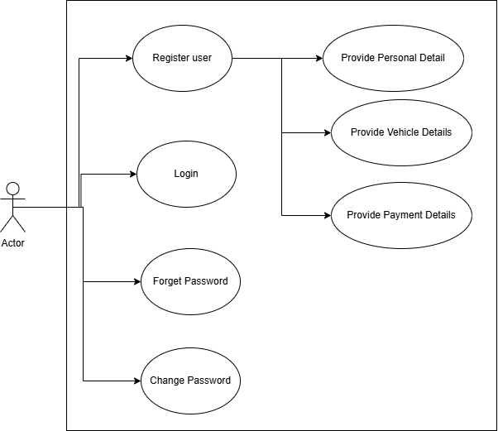

1. Vehicle Management System

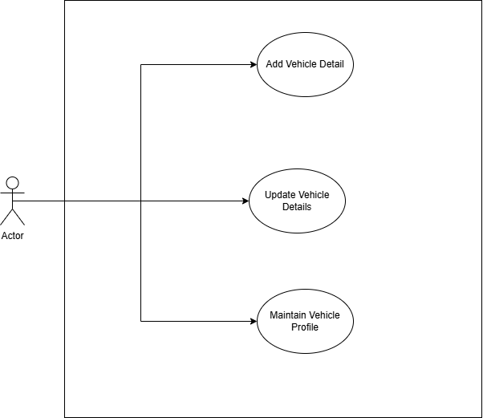

1. Parking Spot Search and Reservation

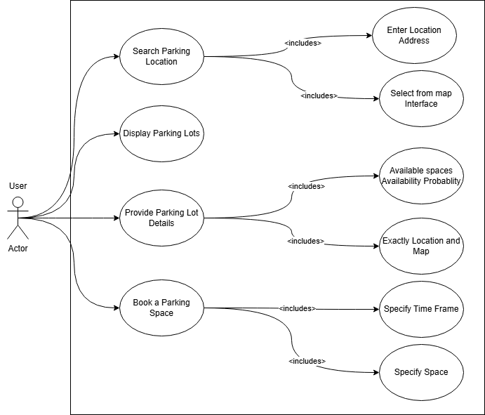

1. Parking Space Booking

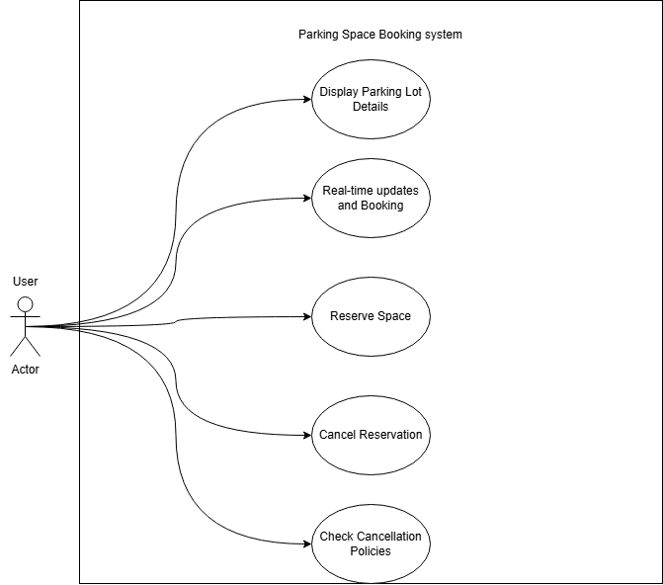

1. Payment and Pricing System

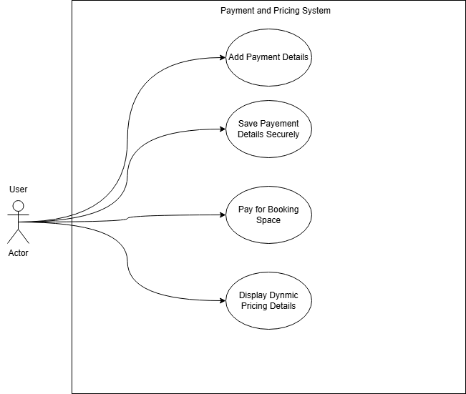

1. User Profile and History System

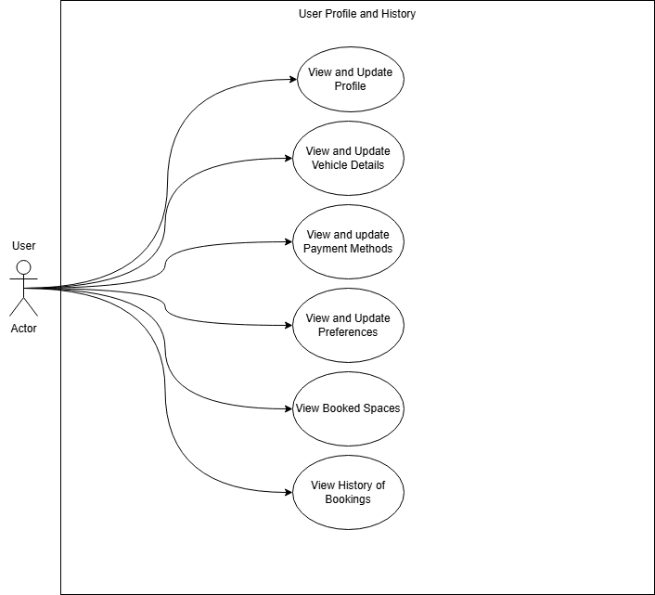

1. Notification and Alerts System

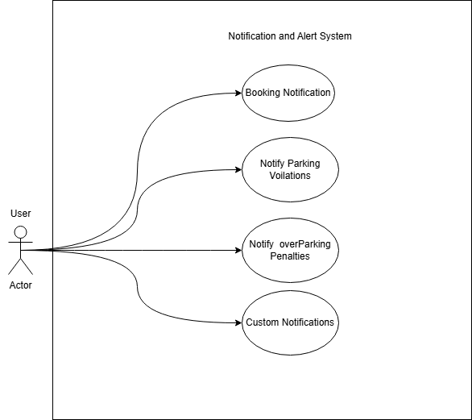

1. Parking Management System

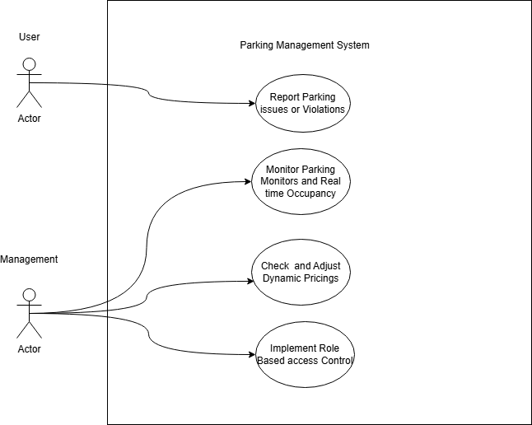

1. Security and Data Privacy

